2D Barcode Scanner

User Manual

1、Product Introduction 6
1.1 Factory default 6
1.2 Get device information 6
2 Wireless settings 6
2.1 Pairing setup code 6
2.2 BLE Bluetooth Mode 7
2.3 Mode Selection 7
2.4 Set the upload data speed delay 8
2.5 Check software version 8
2.6 Set sleep time 9
2.7 USB KBW 9
2.8 USB COM 9
2.10 Output forced letter case conversion 11
2.11 Output format 11
2.12 GS Seting 12
2.13 Battery Query 12
3 Input/Output Settings 12
3.1 Startup Beeper 12
3.2 Trigger Click Beeper 13
3.3 Good Read Beeper 13
3.3.1 Good Read Beeper Volume 13
3.3.2 Good Read Beeper Frequency 13
3.3.3 Good Read Beeper Duration 14
3.3.4 Error Read Beeper Frequency 14
3.3.5 Good Read LED 14
3.4 Manual mode 15
3.5 Induction mode 15
3.5.1 sensitivity 15
3.6 Continuous mode 16
4 Data Editing 17
4.1 Add Preﬁx or Suﬃx 17
4.12 Suﬃx Example 17
4.13 To Add a Suﬃx to All Symbologies 18
4.2 Function Code Transmit 18
5 Barcode symbol parameters 19
5.1 Global operations 19
5.1.1 Operations on all symbol types 19
5.1.2 Operation on all one-dimensional bar code symbol types 19
5.1.3 Operation of all 2D barcode symbol types 19
5.2 Inverse color code setting 20
5.2.1 Operate all reverse color codes 20
5.3 Codabar 20
5.3.1 Enable/Disable Codabar 20
5.3.2 Start/Stop Characters 20
5.3.3 Check Character 21
5.4 Code 39 22
5.4.1 Enable/Disable Code 39 22
5.4.2 Code 39 Start/ Stop Characters 22
5.4.3 Code 39 Message Length 23
5.4.4 Code 39 Check and output check 23
5.4.5 Code 32 Pharmaceutical (PARAF) 23
5.4.6 Code 39 Full ASCII Support 24
5.5 Interleaved 2 of 5 24
5.5.1 Enable /Disable InterLeaved25 24
5.5.2 InterLeaved25 Message Length 24
5.5.3 InterLeaved25 Check and output check 25
5.6 NEC 2 of 5 25
5.6.1 Enable /Disable NEC 2 of 5 25
5.6.2 NEC 2 of 5 Message Length 25
5.6.3 NEC 2 of 5 Check and output check 26
5.7 Code 93 26
5.7.1 Enable/Disable Code 93 26
5.7.2 Code 93 Message Length 26
5.8 Industrial 2 of 5 27
5.8.1 Enable /Disable Industrial 25 27
5.8.2 Industrial 2 of 5 Message Length 27
5.9 Straight 2 of 5 IATA (two-bar start/stop) 27
5.9.1 Enable /Disable Straight 2 of 5 IATA 27
5.9.2 Straight 2 of 5 IATA Message Length 28
5.10 Matrix 2 of 5 28
5.10.1 Enable/Disable Matrix 25 28
5.10.2 Matrix 25 Message Length 28
5.10.3 Check and output check 29
5.11 Code 11 29
5.11.1 Enable/Disable Code 11 29
5.11.2 Code 11 Message Length 29
5.12 Code 128 29
5.12.1 Enable/Disable Code 128 29
5.12.2 ISBT 128 Concatenation 30
5.12.3 Code 128 Message Length 30
5.13 GS1 128 30
5.13.1 Enable/Disable GS1 128 30
5.13.2 GS1 128 Message Length 31
5.14 UPCA 31
5.14.1 Enable/Disable UPCA 31
5.14.2 UPCA Output verification 31
5.14.3 UPCA Output system characters 31
5.14.4 UPCA Extension code 32
5.14.5 UPCA Addenda Required 32
5.14.6 UPCA Addenda Separator 32
5.14.7 UPC-A to EAN-13 33
5.15 UPCE0 33
5.15.1 Enable /Disable UPC-E0 33
5.15.2 Output verification 33
5.15.3 Output system characters 33
5.15.4 UPCE0 Extension code 34
5.15.5 UPCE0 Addenda Required 34
5.15.6 UPCE0 Addenda Separator 34
5.16 UPCE1 35
5.16.1 Enable /Disable UPC-E1 35
5.17 EAN-13 35
5.17.1 Enable/Disable EAN-13 35
5.17.2 EAN 13 Output verification 35
5.17.3 Extension code 35
5.17.4 EAN13 to ISBN 36
5.17.5 EAN13 Addenda Required 36
5.17.6 EAN13 Addenda Separator 36
5.18 EAN-8 37
5.18.1 Enable/Disable EAN-8 37
5.18.2 Output verification 37
5.18.3 Extension code 37
5.18.4 EAN8 Addenda Required 38
5.18.5 EAN8 Addenda Separator 38
5.19 MSI Plessey 38
5.19.1 Enable/Disable MSI Plessey 38
5.19.2 Message Length 38
5.20 GS1 DataBar Omnidirectional 39
5.21 GS1 DataBar Limited 39
5.22 GS1 DataBar Expanded 39
5.23 PDF 417 39
5.24 QR Code 40
5.25 Data Matrix 40
5.26 Aztec Code 40
5.27 China Post (Hong Kong 2 of 5) 40
5.28 Korea Post 40
5.29 Han Xin Code 41
5.30 Maxi Code 41
5.31 Micro pdf417 41
5.32 Gs1 Composite Codes 41
5.32 Codablock A 41
5.33 Disable GS1 Data Matrix 42
6 Data Code 42
6.1 Data code 0~F 42
6.2 Save 43
Appendix A：ASCII Code Table 44

1、Product Introduction

Factory default
- End：Enter(\r)。
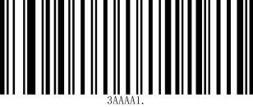
Factory default

Get device information
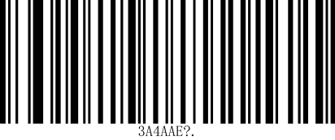
Obtain the version number

2 Wireless settings

2.1 Pairing setup code
①Pair the receiver: Scan the following two barcodes in sequence.And connect the receiver to computer；
 | 
2.4G Mode | Connect

②Pair Bluetooth devices in HID mode: Scan the following two barcodes in sequence, turn on the Bluetooth device to search for RB_Scanner_HID connection.


HIDMode | Connect

2.2 BLE Bluetooth Mode
Pairing Bluetooth devices: Scan the following two barcodes in sequence, and perform Bluetooth search RB_Scanner_BLE on the software that supports BLE
Connect.Note: BLE mode needs to be output on specific software (Bluetooth serial port)

BLE Mode | Connect

2.3 Mode Selection
 | 
Instant upload mode | Inventory Mode

*Over-the-distance storage mode

①Operations in Inventory Mode
 | 
Upload all data | Upload new data (that is, data that has not been uploaded before)
 | 
Display saved data | Showing unuploaded data

Clear all data

2.4 Set the upload data speed delay
 | 
*No delay | Delay 10ms

Delay 20ms

2.5 Check software version
 | 
Check the scanner software version | Check the receiving end version number

2.6 Set sleep time
 | 
No sleep | *1min
 | 
2min | 5min

10min

2.7 USB KBW
When the scanner is connected to the host using a USB receiver, the scanner can be configured as a standard keyboard input by scanning the USB KBW setup code.

*USB KBW keyboard

2.8 USB COM
When the scanner is connected to the host using a USB receiver, the receiver virtual serial port output mode can be changed by scanning the USB COM setup code.

USB COM

2.9 multi-language keyboards
When the scanner recognizes it as a keyboard input device, different countries have different input characters, so you need to set different national languages. The keyboard defaults to the US language.
 | 
*U.S | Belgium (French)
 | 
Brazil (Portuguese) | Canada
 | 
Czech | Denmark
 | 
Finland | France
 | 
Germany | Italy
 | 
Portugal | Spain
 | 
Türkiye-F | Türkiye-Q
 | 
U.K. | Japan
 | 
Russia | Vietnamese

2.10 Output forced letter case conversion
Letter conversion, when outputting barcodes with letter content, you can configure the output result to be all uppercase or all lowercase. For example, if the barcode content is: ab123dE, if you scan the "Convert to uppercase" barcode, the output result is: AB123DE; if you scan the "Convert to lowercase" barcode, the output result is: abc123de; the default case is not converted.
 | 
*Do not convert | Uppercase
 | 
Lowercase | Case conversion

2.11 Output format
 | 
*UTF-8 | GBK

2.12 GS Seting
 | 
*Eanble GS | Disable GS

2.13 Battery Query


After scanning the setup code, the battery percentage will be output

3 Input/Output Settings
This chapter mainly introduces the conﬁguration of the beep and LED of the barcode scanner when it is powered on, decoded, and triggered by the button.

3.1 Startup Beeper
The scanner can be programmed to beep when it’s started up. Default = Startup Beeper On.
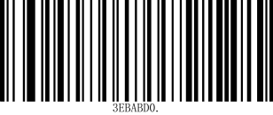 | 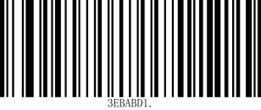
Startup Beeper Off | * Startup Beeper On

3.2 Trigger Click Beeper
To hear an audible click every time the scanner button is pressed, scan the Trigger Click Beeper On barcode below. Default = Trigger Click Beeper Off.
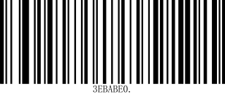 | 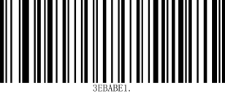
*Trigger Click Beeper Off | Trigger Click Beeper On

3.3 Good Read Beeper
The beeper may be programmed On or Off in response to a good read. Default = Good Read Beeper On.

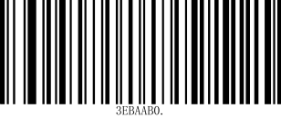 | 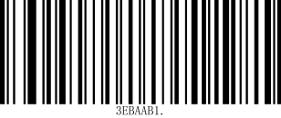
Good Read Beeper Off | * Good Read Beeper On

3.3.1 Good Read Beeper Volume
The beeper volume codes modify the volume of the beep the scanner emits on a good read. Default = High.

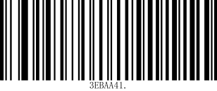 | 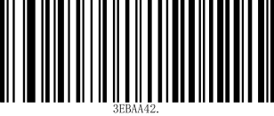
Low | Medium
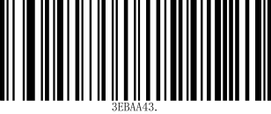 | 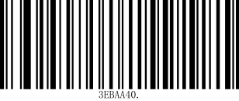
* High | Off

3.3.2 Good Read Beeper Frequency
The beeper frequency codes modify the frequency of the beep the scanner emits on a good read. Default = Medium.

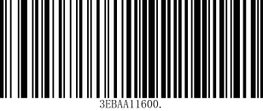 | 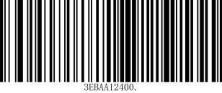
Low (1600 Hz) | * Medium (2400 Hz)
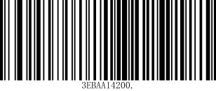
High (4200 Hz)

3.3.3 Good Read Beeper Duration
The beeper duration codes modify the length of the beep the scanner emits on a good read. Default = Normal .
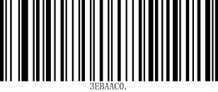 | 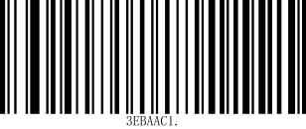
* Normal | Short

3.3.4 Error Read Beeper Frequency
The beeper frequency codes modify the frequency of the sound the scan- ner emits when there is a bad read or error. Default = Razz.
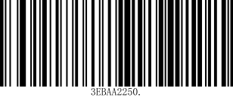 | 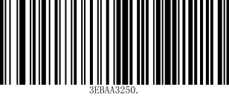
* Razz (250 Hz) | Medium (3250 Hz)
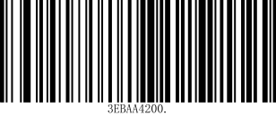
High (4200 Hz)

3.3.5 Good Read LED
The LED indicator can be programmed On or Off in response to a good read. Default = On.
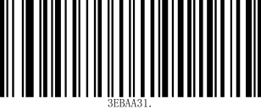 | 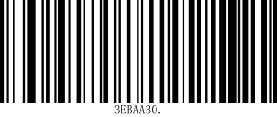
* Good Read LED On | Good Read LED Off

3.4 Manual mode
The manual reading mode is the default reading mode. In this mode, the recognition engine starts reading the code after the user presses the trigger key, and stops reading the code after successfully outputting information or the user releases the trigger key.
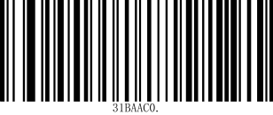
*Manual mode

3.5 Induction mode
After setting up, there is no need to trigger, and the recognition engine immediately starts monitoring the brightness of the surrounding environment. When the scene changes, the recognition engine waits for the set stabilization time to end before starting to read the code. If the following situation does not occur, the reading engine will cycle in the above way: if the barcode is not scanned within a single reading time, the reading engine will automatically pause reading and enter the monitoring state. In the induction reading mode, the reading engine can also start reading the code after the user presses the trigger button. When the code reading is successful and outputs information or the user releases the trigger button, it will switch to induction mode for 5 seconds and continue to monitor the brightness of the surrounding environment.
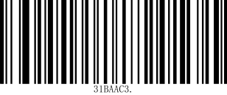
Induction mode

3.5.1 sensitivity
Self sensing sensitivity, the higher the sensitivity, the easier it is to wake up, but it is easy to accidentally wake up the device to decoding mode, default to high.
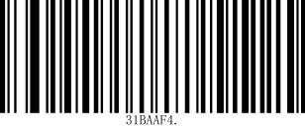 | 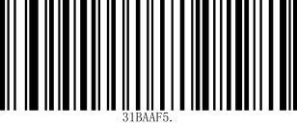
High* | Mid
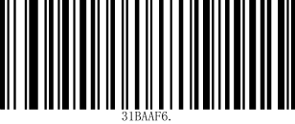
Low

3.6 Continuous mode
After setting up, there is no need to trigger. The reading engine immediately starts reading the code. During the reading process, the user can also manually pause the reading by clicking the trigger button. When the reading is successful and outputs information or the user releases the trigger button, it will switch to continuous mode for 5 seconds
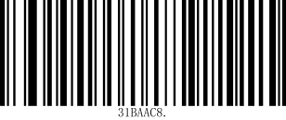
Continuous mode

3.61 Same barcode reading delay
Sensing mode and continuous mode scanning can be used to set the time interval between barcode scanning equipment reading the next barcode after reading one barcode。
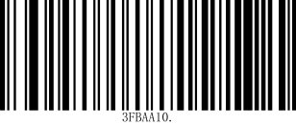 | 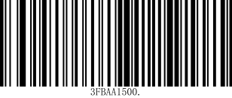
No time interval | *500MS
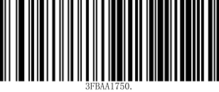 | 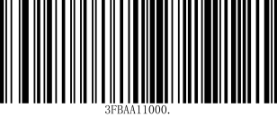
750MS | 1000MS
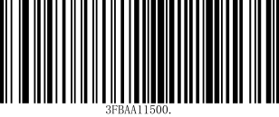
1500MS

4 Data Editing

4.1 Add Preﬁx or Suﬃx
Step 1. Scan the Add Preﬁx or Add Suﬃx symbol
Step 2. Determine the 2 digit Hex value from the Symbology Chart for the symbology to which you want to apply the preﬁx or suﬃx. For example, for Code 11, Code ID is “h” and Hex ID is “68”.
Step 3. Scan the 2 hex digits from the Programming Chart inside the back cover of this manual or scan 9, 9 for all symbologies.
Step 4. Determine the hex value from the ASCII Conversion Chart , for the preﬁx or suﬃx you wish to enter.
Step 5. Scan the 2 digit hex value from the Programming Chart inside the back cover of this manual.
Step 6. Repeat Steps 4 and 5 for every preﬁx or suﬃx character.
Step 7. Scan Save to exit and save, or scan Discard to exit without saving.
 | 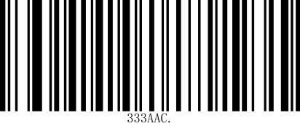
Add Suﬃx | Add Suﬃx

4.12 Suﬃx Example
Add a Suﬃx to a speciﬁc symbology
To send a CR (carriage return)Suﬃx for code 128. only:
Step 1. Scan Add Suﬃx.
Step 2. Determine the 2 digit hex value from the Symbology Charts for code 128.
Step 3. Scan 6, 3 from the Programming Chart inside the back cover of this manual.
Step 4. Determine the hex value from the ASCII Conversion Chart , for the CR (carriage return).
Step 5. Scan 0, D from the Programming Chart inside the back cover of this manual.
Step 6. Scan Save, or scan Discard to exit without saving.
Step 1 | Step 2
Add Suﬃx | 6
Step 3 | Step 4
A | 0
Step 5 | Step 6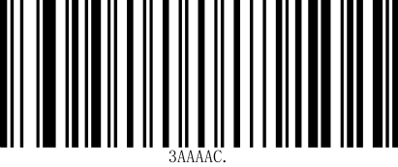
D | Save

4.13 To Add a Suﬃx to All Symbologies
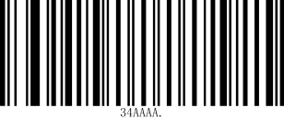 | 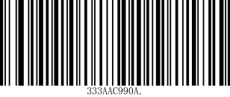
*Add CR Suﬃx All Symbologies | Add LF Suﬃx All Symbologies
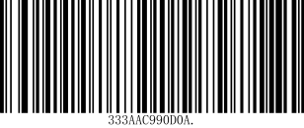 | 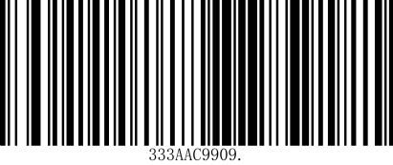
Add CR and LF Suﬃx All Symbologies | Add tab Suﬃx All Symbologies

4.2 Function Code Transmit
When this selection is enabled and function codes are contained within the scanned data, the scanner transmits the function code to the terminal. Default = Disable
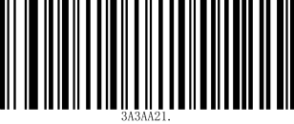 | 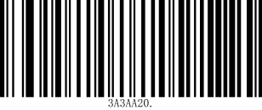
Enable | *Disable

5 Barcode symbol parameters

5.1 Global operations

5.1.1 Operations on all symbol types
Reading the following setting codes will operate on all supported symbol types, allowing or prohibiting reading. After prohibiting reading all types, only setting codes are allowed to be read.

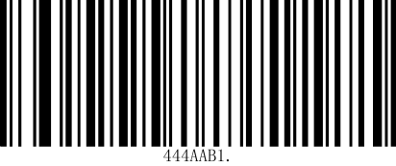 | 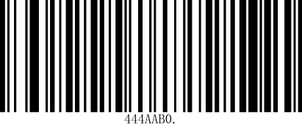
Allow reading all types | Prohibit reading all types

5.1.2 Operation on all one-dimensional bar code symbol types
Read the following setting codes, and only perform unified operations on all one-dimensional bar code symbol types, or all allow reading, or all prohibit reading.

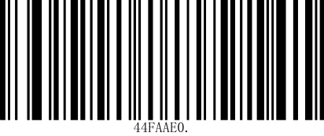 | 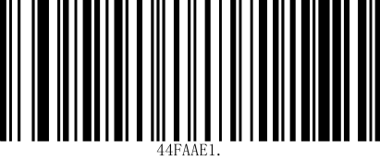
Allows to read all one-dimensional barcode types | Prohibit reading all 1D barcode type

5.1.3 Operation of all 2D barcode symbol types
Read the following setting codes, and only perform unified operations on all 2D barcode symbol types, or all allow reading, or all prohibit reading.

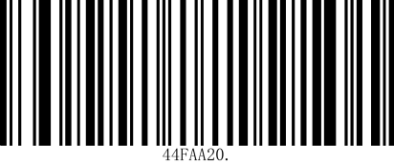 | 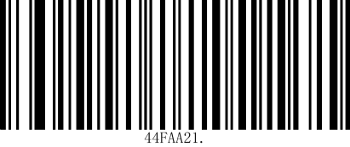
Allow to read all 2D barcode types | Prohibit reading all QR code types

5.2 Inverse color code setting
If this configuration is turned on, the recognition speed will be affected. Please turn it on in the scene you need to use.

5.2.1 Operate all reverse color codes

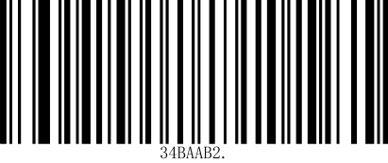 | 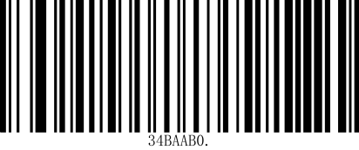
Allow to read the reverse color code | *Prohibit read the reverse color code

5.3 Codabar

5.3.1 Enable/Disable Codabar

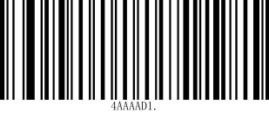 | 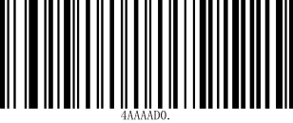
Enable Codabar | Disable Codabar

5.3.2 Start/Stop Characters
Start/Stop characters identify the leading and trailing ends of the barcode. You may either transmit, or not transmit Start/Stop characters.Default = Don’t Transmit.

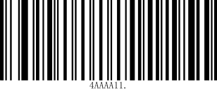 | 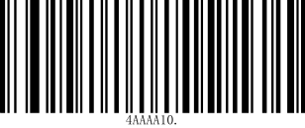
Transmit | * Don’t Transmit

5.3.3 Check Character
No Check Character indicates that the scanner reads and transmits barcode data with or without a check character.
When Check Character is set to Validate and Transmit, the scanner will only read Codabar barcodes printed with a check character, and will transmit this character at the end of the scanned data.
When Check Character is set to Validate, but Don’t Transmit, the unit will only read Codabar barcodes printed with a check character, but will not transmit the check character with the scanned data. Default = No Check Character.
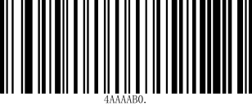 | 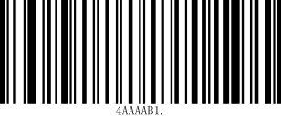
* No Check Character | Validate but Don’t Transmit
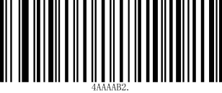
Validate and Transmit

5.3.4 Concatenation
Codabar supports symbol concatenation. When you enable concatena- tion, the scanner looks for a Codabar symbol having a “D” start character, adjacent to a symbol having a “D” stop character. In this case the two mes- sages are concatenated into one with the “D” characters omitted.

A 1 2 3 4 D D 5 6 7 8A
Select Require to prevent the scanner from decoding a single “D” Codabar symbol without its companion. This selection has no effect on Codabar symbols without Stop/Start D characters.
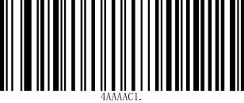 | 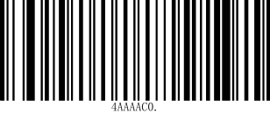
On | * Off
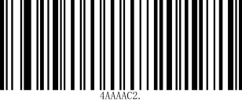
Require
5.3.5 Message Length
Scan the barcodes below to change the message length. Refer to Message Length Description for additional information. Minimum and Maximum lengths = 2-60. Minimum Default = 4, Maximum Default = 60.
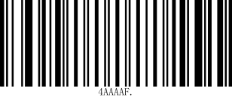 | 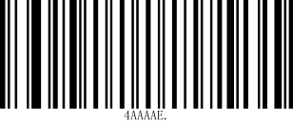
Minimum Message Length | Maximum Message Length

5.4 Code 39

5.4.1 Enable/Disable Code 39
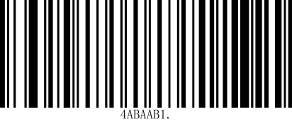 | 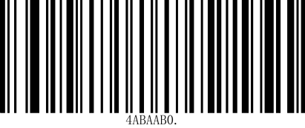
*Enable Code 39 | Disable Code 39

5.4.2 Code 39 Start/ Stop Characters
Start/Stop characters identify the leading and trailing ends of the barcode. You may either transmit, or not transmit Start/Stop characters. Default = Don’t Transmit.
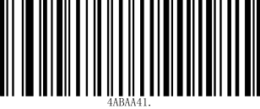 | 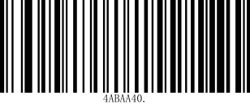
Transmit | * Don’t Transmit

5.4.3 Code 39 Message Length
Scan the barcodes below to change the message length. Refer to Message Length Description for additional information. Minimum and Maximum lengths
= 0-48. Minimum Default = 0, Maximum Default = 48.
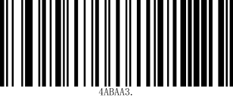 | 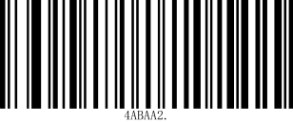
Minimum Message Length | Maximum Message Length

5.4.4 Code 39 Check and output check
No Check Character indicates that the scanner reads and transmits bar- code data with or without a check character.
When Check Character is set to Validate, but Don’t Transmit, the unit only reads Code 39 barcodes printed with a check character, but will not transmit the check character with the scanned data.
When Check Character is set to Validate and Transmit, the scanner only reads Code 39 barcodes printed with a check character, and will transmit this character at the end of the scanned data. Default = No Check Character.

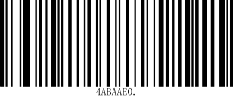
* No Check Character
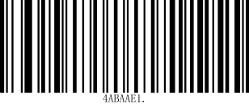 | 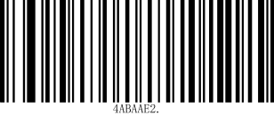
Validate, but Don’t Transmit | Validate and Transmit

5.4.5 Code 32 Pharmaceutical (PARAF)
Code 32 Pharmaceutical is a form of the Code 39 symbology used by Ital- ian pharmacies. This symbology is also known as PARAF.
When you conﬁgure code32, you need to turn on code39 before you conﬁgure it.

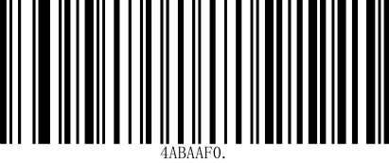 | 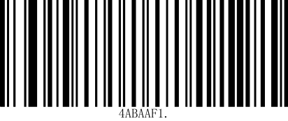
*Disable Code32 | Enable Code32

5.4.6 Code 39 Full ASCII Support
The encoding method of Code 39 can include the representation of all ASCII characters. By setting, the reading module can support bar codes containing the full ASCII character set.

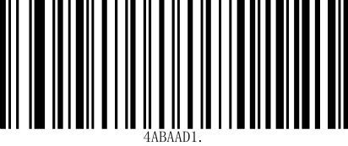 | 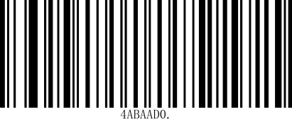
Enable Full ASCII | *Disable Full ASCII

5.5 Interleaved 2 of 5

5.5.1 Enable /Disable InterLeaved25
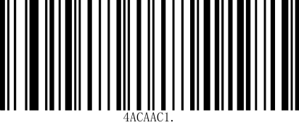 | 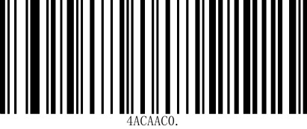
*Enable InterLeaved25 | Disable InterLeaved25

5.5.2 InterLeaved25 Message Length
Scan the barcodes below to change the message length. Refer to Message Length Description for additional information. Minimum and Maximum lengths= 2-80. Minimum Default = 4, Maximum Default = 80.

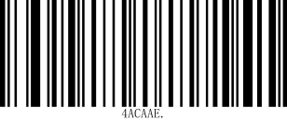 | 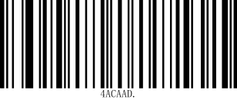
Minimum Message Length | Maximum Message Length

5.5.3 InterLeaved25 Check and output check
No Check Digit indicates that the scanner reads and transmits barcode data with or without a check digit.
When Check Digit is set to Validate, but Don’t Transmit, the unit only reads Interleaved 2 of 5 barcodes printed with a check digit, but will not transmit the check digit with the scanned data.
When Check Digit is set to Validate and Transmit, the scanner only reads Interleaved 2 of 5 barcodes printed with a check digit, and will transmit this digit at the end of the scanned data. Default = No Check Digit.

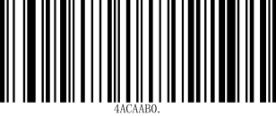
* No Check Character
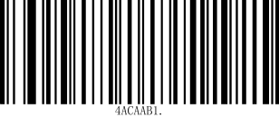 | 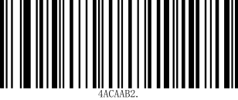
Validate, but Don’t Transmit | Validate and Transmit

5.6 NEC 2 of 5

5.6.1 Enable /Disable NEC 2 of 5
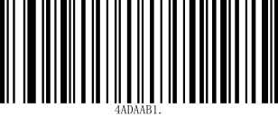 | 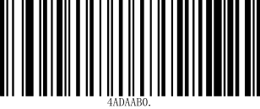
*Enable InterLeaved25 | Disable InterLeaved25

5.6.2 NEC 2 of 5 Message Length
Scan the barcodes below to change the message length. Refer to Message Length Description for additional information. Minimum and Maximum lengths= 2-80. Minimum Default = 4, Maximum Default = 80.

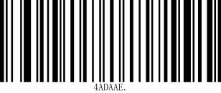 | 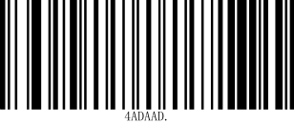
Minimum Message Length | Maximum Message Length

5.6.3 NEC 2 of 5 Check and output check
No Check Digit indicates that the scanner reads and transmits barcode data with or without a check digit.
When Check Digit is set to Validate, but Don’t Transmit, the unit only reads NEC 2 of 5 barcodes printed with a check digit, but will not transmit the check digit with the scanned data.
When Check Digit is set to Validate and Transmit, the scanner only reads NEC 2 of 5 barcodes printed with a check digit, and will transmit this digit at the end of the scanned data. Default = No Check Digit

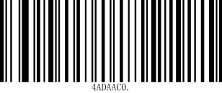
* No Check Character
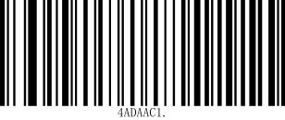 | 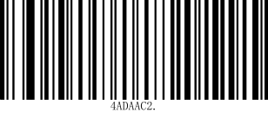
Validate, but Don’t Transmit | Validate and Transmit

5.7 Code 93

5.7.1 Enable/Disable Code 93
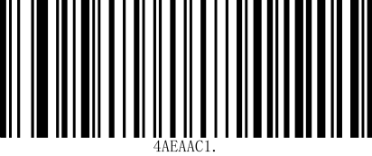 | 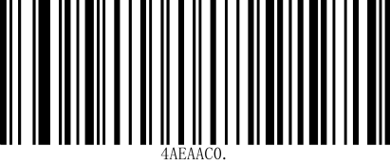
*Enable Code 93 | Disable Code 93

5.7.2 Code 93 Message Length
Scan the barcodes below to change the message length. Refer to Message Length Description for additional information. Minimum and Maximum lengths = 0-80. Minimum Default = 0, Maximum Default = 80.

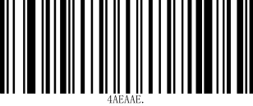 | 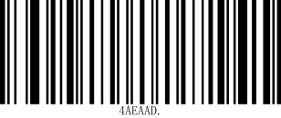
Minimum Message Length | Maximum Message Length

5.8 Industrial 2 of 5

5.8.1 Enable /Disable Industrial 25
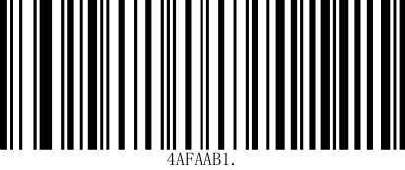 | 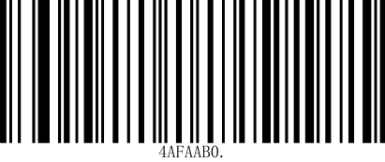
Enable Industrial 25 | *Disable Industrial 25

5.8.2 Industrial 2 of 5 Message Length
Scan the barcodes below to change the message length. Refer to Message Length Description for additional information. Minimum and Maximum lengths = 1-48. Minimum Default = 4, Maximum Default = 48.

Minimum Message Length | Maximum Message Length

5.9 Straight 2 of 5 IATA (two-bar start/stop)

5.9.1 Enable /Disable Straight 2 of 5 IATA
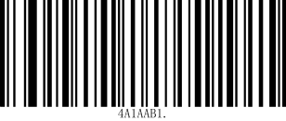 | 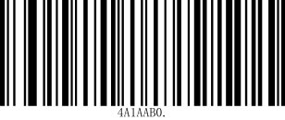
Enable Straight 2 of 5 IATA | *Disable Straight 2 of 5 IATA

5.9.2 Straight 2 of 5 IATA Message Length
Scan the barcodes below to change the message length. Refer to Message Length Description for additional information. Minimum and Maximum lengths = 1-48. Minimum Default = 4, Maximum Default = 48.

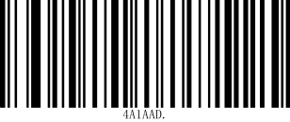 | 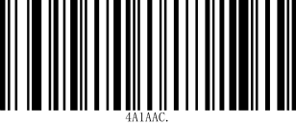
Minimum Message Length | Maximum Message Length

5.10 Matrix 2 of 5

5.10.1 Enable/Disable Matrix 25

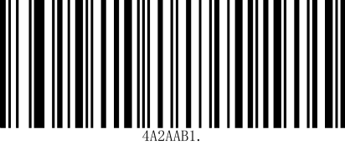 | 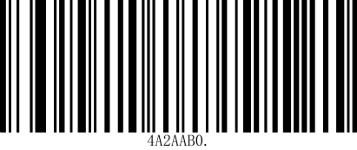
Enable Matrix 25 | *Disable Matrix 25

5.10.2 Matrix 25 Message Length
Scan the barcodes below to change the message length. Refer to Message Length Description for additional information. Minimum and Maximum lengths = 1-80. Minimum Default = 4, Maximum Default = 80.

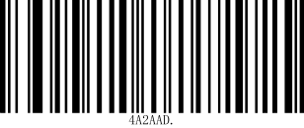 | 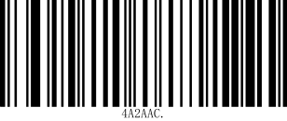
Minimum Message Length | Maximum Message Length

5.10.3 Check and output check
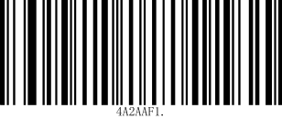 | 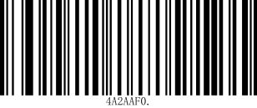
Enable Check Function | Disable Check Function

5.11 Code 11

5.11.1 Enable/Disable Code 11
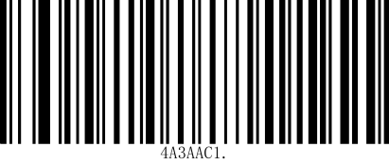 | 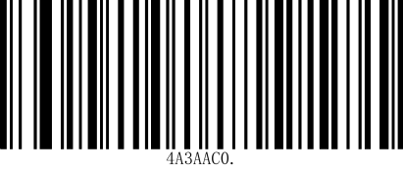
Enable Code 11 | *Disable Code11

5.11.2 Code 11 Message Length
Scan the barcodes below to change the message length. Refer to Message Length Description for additional information. Minimum and Maximum lengths = 1-80. Minimum Default = 4, Maximum Default = 80.

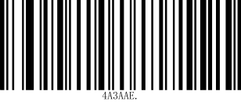 | 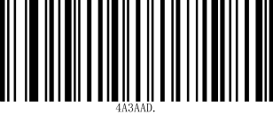
Minimum Message Length | Maximum Message Length

5.12 Code 128

5.12.1 Enable/Disable Code 128

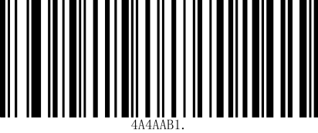 | 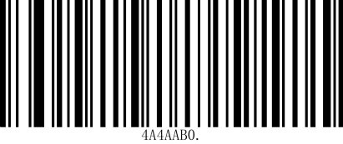
*Enable Code 128 | Disable Code 128

5.12.2 ISBT 128 Concatenation

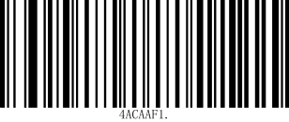 | 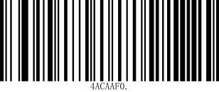
ISBT 128 On | *ISBT 128 Off

5.12.3 Code 128 Message Length
Scan the barcodes below to change the message length. Refer to Message Length Description for additional information. Minimum and Maximum lengths = 1-80. Minimum Default =1, Maximum Default = 80.

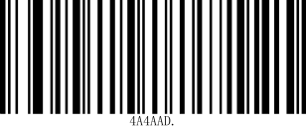 | 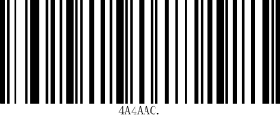
Minimum Message Length | Maximum Message Length

5.13 GS1 128

5.13.1 Enable/Disable GS1 128

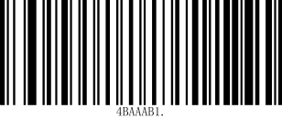 | 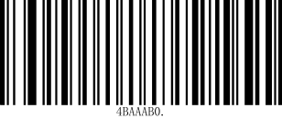
*Enable GS1 128 | Disable GS1 128

5.13.2 GS1 128 Message Length
Scan the barcodes below to change the message length. Refer to Message Length Description for additional information. Minimum and Maximum lengths = 1-80. Minimum Default = 1, Maximum Default = 80.

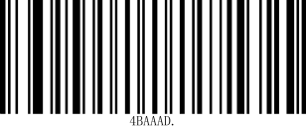 | 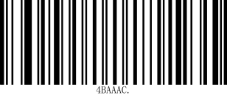
Minimum Message Length | Maximum Message Length

5.14 UPCA

5.14.1 Enable/Disable UPCA
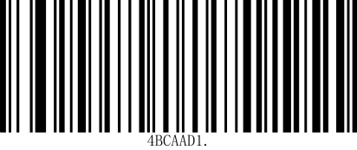 | 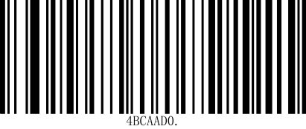
*Enable UPCA | Disable UPCA

5.14.2 UPCA Output verification
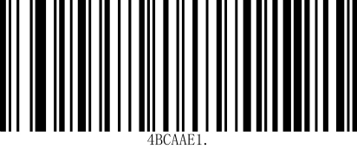 | 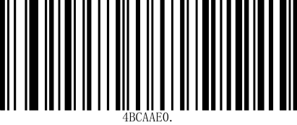
*Output check | No output check

5.14.3 UPCA Output system characters
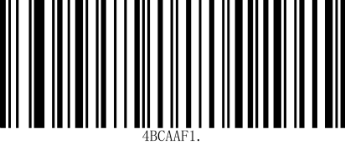 | 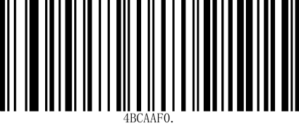
*Output system characters | No output system characters

5.14.4 UPCA Extension code
After setting to "Read 2-digit extension code" or "Read 5-digit extension code", the reader module can read barcode symbols with extension codes, or barcode symbols without extension codes. After setting to "Do not read 2-digit extension code" or "Do not read 5-digit extension code", the extension code attached to the bar code symbol will not be read and output.

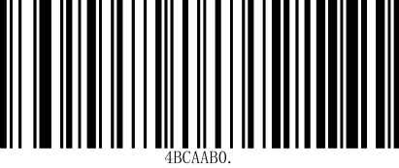 | 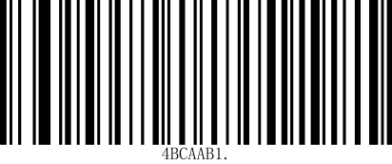
*Disable 2-digit extension code | Enable 2-digit extension code
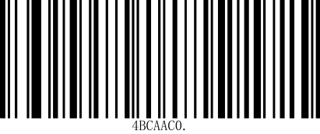 | 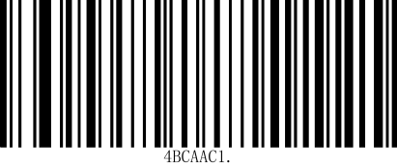
*Disable 5-digit extension code | Enable 5-digit extension code

5.14.5 UPCA Addenda Required
When Required is scanned, the scanner will only read UPC-A barcodes that have addenda. You must then turn on a 2 or 5 digit addenda. Default = Not Required.
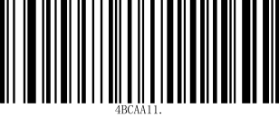 | 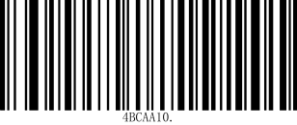
Required | * Not Required

5.14.6 UPCA Addenda Separator
When this feature is on, there is a space between the data from the barcode and the data from the addenda. When turned off, there is no space. Default= On.

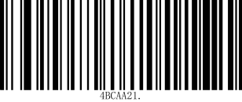 | 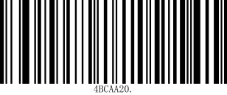
*On | Off

5.14.7 UPC-A to EAN-13

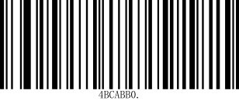 | 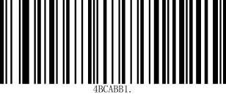
On | *Off

5.15 UPCE0

5.15.1 Enable /Disable UPC-E0
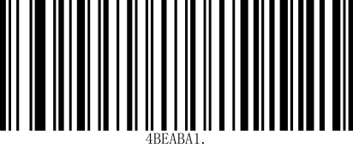 | 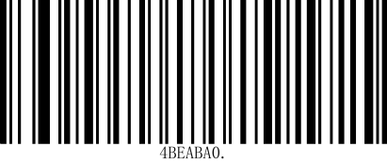
*Enable UPCE0 | Disable UPCE0

5.15.2 Output verification
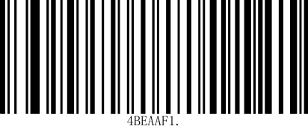 | 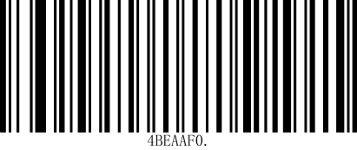
*Output check | No Output check

5.15.3 Output system characters
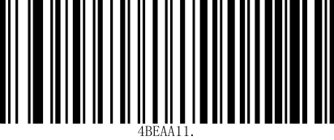 | 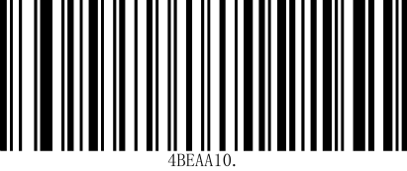
*Output system characters | No output system characters

5.15.4 UPCE0 Extension code
After setting to "Read 2-digit extension code" or "Read 5-digit extension code", the reader module can read barcode symbols with extension codes, or barcode symbols without extension codes. After setting to "Do not read 2-digit extension code" or "Do not read 5-digit extension code", the extension code attached to the bar code symbol will not be read and output.

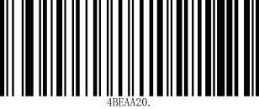 | 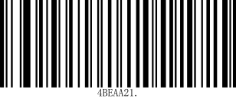
*Disable 2-digit extension code | Enable 2-digit extension code
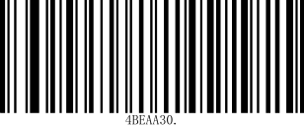 | 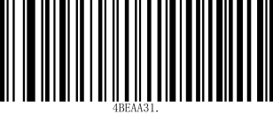
*Disable 5-digit extension code | Enable 5-digit extension code

5.15.5 UPCE0 Addenda Required
When Required is scanned, the scanner will only read UPC-A barcodes that have addenda. You must then turn on a 2 or 5 digit addenda. Default = Not Required.
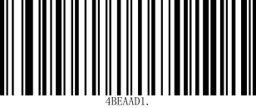 | 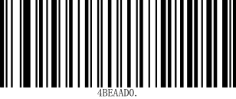
Required | * Not Required

5.15.6 UPCE0 Addenda Separator
When this feature is on, there is a space between the data from the barcode and the data from the addenda. When turned off, there is no space. Default= On.

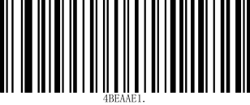 | 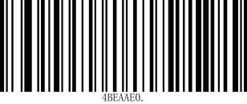
*On | Off

5.16 UPCE1

5.16.1 Enable /Disable UPC-E1
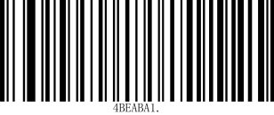 | 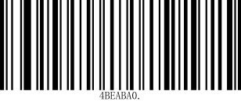
*Enable UPCE1 | Disable UPCE1

5.17 EAN-13

5.17.1 Enable/Disable EAN-13
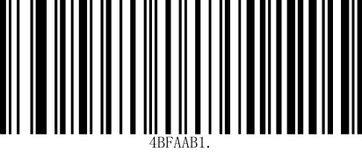 | 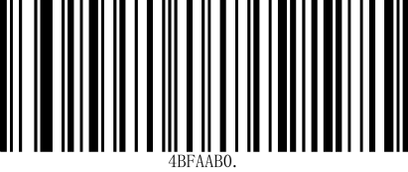
*Enable EAN-13 | Disable EAN-13

5.17.2 EAN 13 Output verification

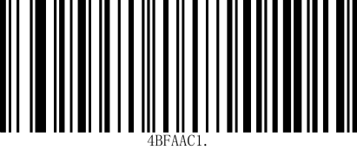 | 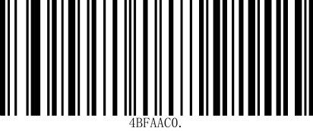
*Output check | No Output check

5.17.3 Extension code
After setting to "Read 2-digit extension code" or "Read 5-digit extension code", the reader module can read barcode symbols with extension codes, or barcode symbols without extension codes. After setting to "Do not read 2-digit extension code" or "Do not read 5-digit extension code", the extension code attached to the bar code symbol will not be read and output.

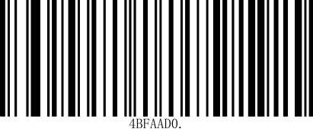 | 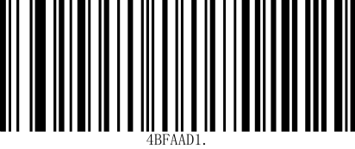
*Disable 2-digit extension code | Enable 2-digit extension code
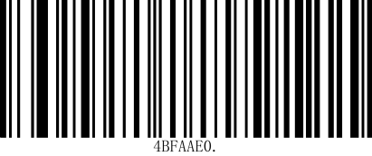 | 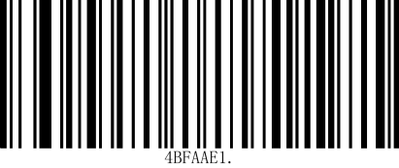
*Disable 5-digit extension code | Enable 5-digit extension code

5.17.4 EAN13 to ISBN
Other configurations are the same as EAN13.

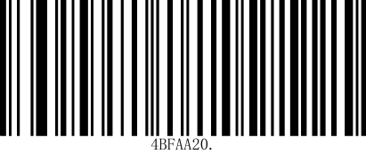 | 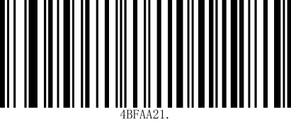
*Disable EAN13 to ISSN | Enable EAN13 to ISSN

5.17.5 EAN13 Addenda Required
When Required is scanned, the scanner will only read UPC-A barcodes that have addenda. You must then turn on a 2 or 5 digit addenda. Default = Not Required.
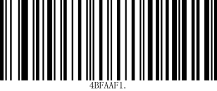 | 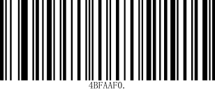
Required | * Not Required

5.17.6 EAN13 Addenda Separator
When this feature is on, there is a space between the data from the barcode and the data from the addenda. When turned off, there is no space. Default= On.
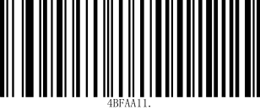 | 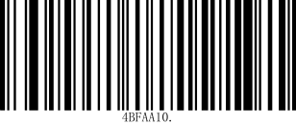
*On | Off

5.18 EAN-8

5.18.1 Enable/Disable EAN-8
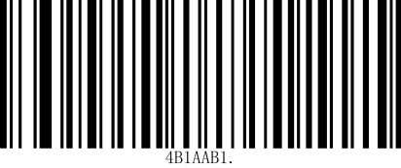 | 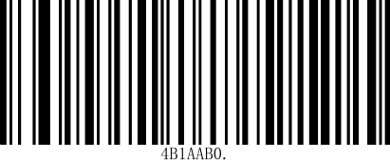
Enable EAN-8 | *Disable EAN-8

5.18.2 Output verification
EAN-8 The barcode data is fixed to 8 bytes, of which the last byte is the checksum.

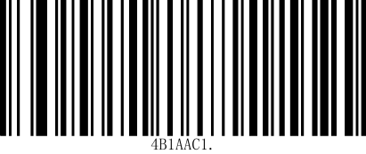 | 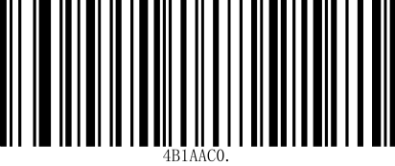
*Output check | No output check

5.18.3 Extension code
After setting to "Read 2-digit extension code" or "Read 5-digit extension code", the reader module can read barcode symbols with extension codes, or barcode symbols without extension codes. After setting to "Do not read 2-digit extension code" or "Do not read 5-digit extension code", the extension code attached to the bar code symbol will not be read and output.

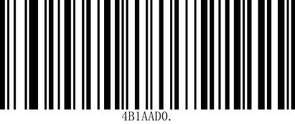 | 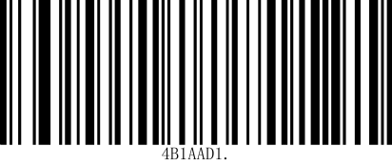
*Disable 2-digit extension code | Enable 2-digit extension code
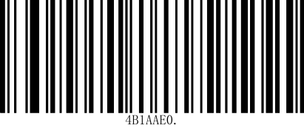 | 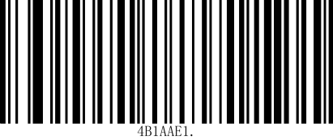
*Disable 5-digit extension code | Enable 5-digit extension code

5.18.4 EAN8 Addenda Required
When Required is scanned, the scanner will only read UPC-A barcodes that have addenda. You must then turn on a 2 or 5 digit addenda. Default = Not Required.
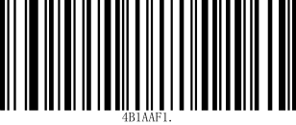 | 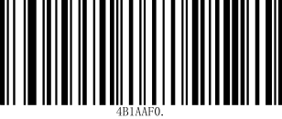
Required | * Not Required

5.18.5 EAN8 Addenda Separator
When this feature is on, there is a space between the data from the barcode and the data from the addenda. When turned off, there is no space. Default= On.

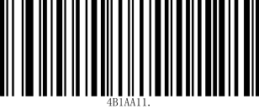 | 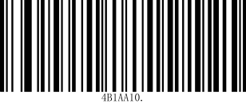
*On | Off

5.19 MSI Plessey

5.19.1 Enable/Disable MSI Plessey
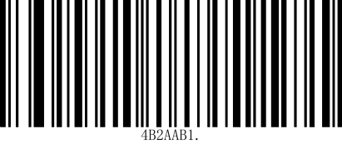 | 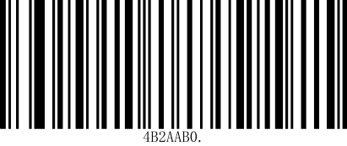
Enable MSI Plessey | *Disable MSI Plessey

5.19.2 Message Length
Scan the barcodes below to change the message length. Refer to Message Length Description for additionalinformation. Minimum and Maximum lengths = 4-48. Minimum Default = 4, Maximum Default = 48.

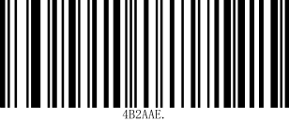 | 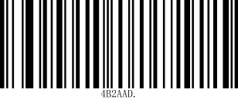
Minimum Message Length | Maximum Message Length

5.20 GS1 DataBar Omnidirectional
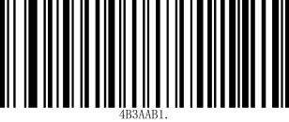 | 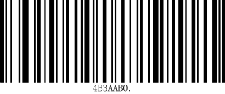
*Enable GS1 DataBar Omnidirectional | Disable GS1 DataBar Omnidirectional

5.21 GS1 DataBar Limited
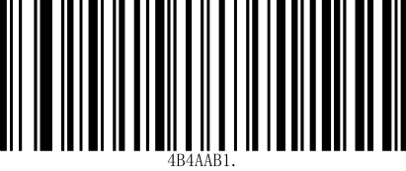 | 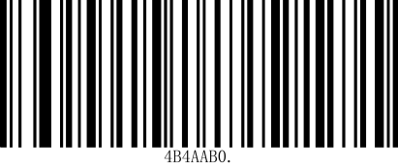
*Enable GS1 DataBar Limited | Disable GS1 DataBar Limited

5.22 GS1 DataBar Expanded
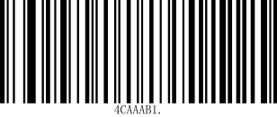 | 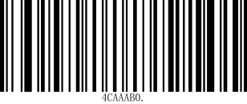
*Enable GS1 DataBar Expanded | Disable GS1 DataBar Expanded

5.23 PDF 417
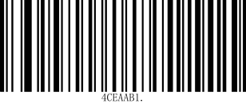 | 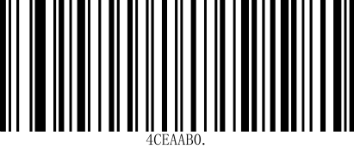
*Enable PDF 417 | Disable PDF 417

5.24 QR Code
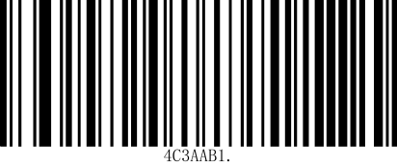 | 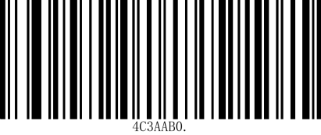
*Enable QR | Disable QR

525 Data Matrix
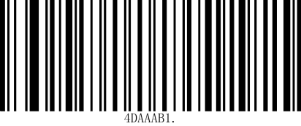 | 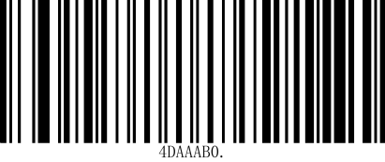
*Enable Data Matrix | Disable Data Matrix

5.26 Aztec Code
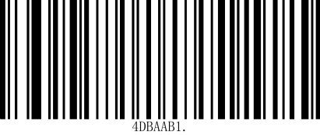 | 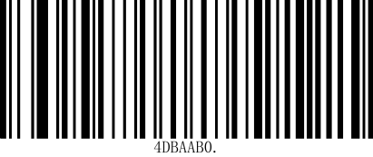
Enable Aztec Code | *Disable Aztec Code

5.27 China Post (Hong Kong 2 of 5)
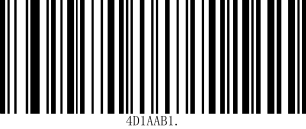 | 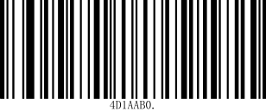
Enable China Post (Hong Kong 2 of 5) | *Disable China Post (Hong Kong 2 of 5)

5.28 Korea Post
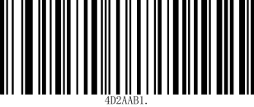 | 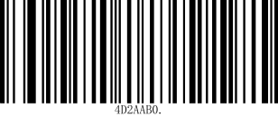
Enable Korea Post | *Disable Korea Post

5.29 Han Xin Code
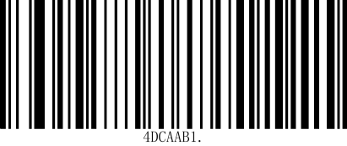 | 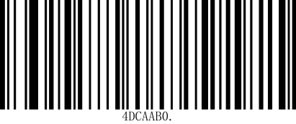
Enable Han Xin Code | *Disable Han Xin Code

5.30 Maxi Code
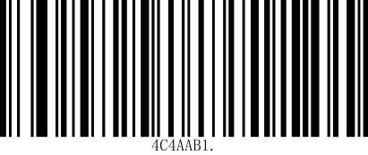 | 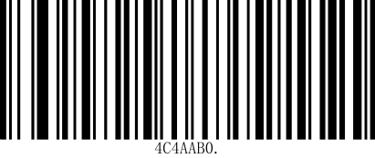
Enable Maxi Code | *Disable Maxi Code

5.31 Micro pdf417
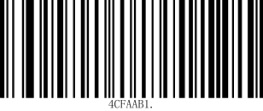 | 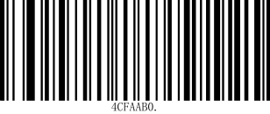
*Enable Micro pdf417 | Disable Micro pdf417

5.32 Gs1 Composite Codes
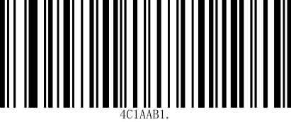 | 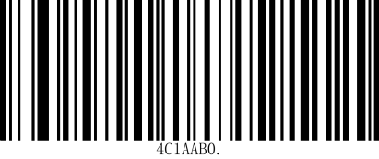
Enable Gs1 Composite Codes | *Disable Gs1 Composite Codes

5.32 Codablock A
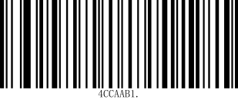 | 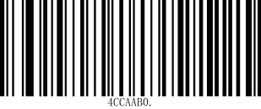
Enable Codablock A | *Disable Codablock A

5.33 Disable GS1 Data Matrix
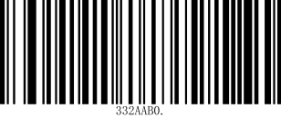 | 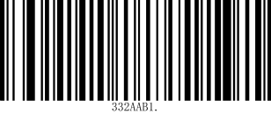
Enable GS1 Data Matrix | *Disable GS1 Data Matrix

6 Data Code

6.1 Data code 0~F
 | 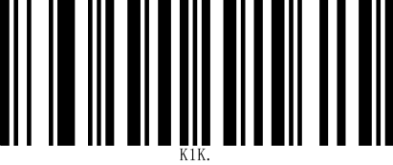
Data Code0 | Data Code1
 | 
Data Code2 | Data Code3
 | 
Data Code4 | Data Code5
 | 
Data Code6 | Data Code7
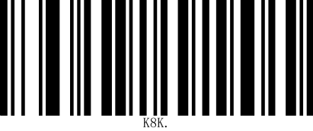 | 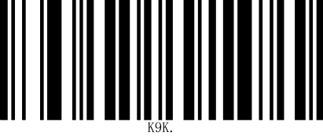
Data Code8 | Data Code9
 | 
Data CodeA | Data CodeB

Data CodeC | Data CodeD
 | 
Data CodeE | Data CodeF

6.2 Save
 | 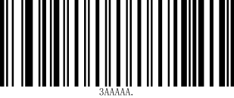
Save | Discard
Note: If an error occurs while scanning a letter or number (before scanning the "Save" barcode), scan the "Discard" barcode, rescan the correct letter or number, and then scan the "Save" barcode.

Appendix A：ASCII Code Table
Hexadecimal | Decimal | Character
00 | 0 | NUL (Nullchar.)
01 | 1 | SOH (StartofHeader)
02 | 2 | STX (Start ofText)
03 | 3 | ETX (End ofText)
04 | 4 | EOT (EndofTransmission)
05 | 5 | ENQ (Enquiry)
06 | 6 | ACK (Acknowledgment)
07 | 7 | BEL (Bell)
08 | 8 | BS (Backspace)
09 | 9 | HT (HorizontalTab)
0a | 10 | LF (LineFeed)
0b | 11 | VT (VerticalTab)
0c | 12 | FF (FormFeed)
0d | 13 | CR (CarriageReturn)
0e | 14 | SO (ShiftOut)
0f | 15 | SI (ShiftIn)
10 | 16 | DLE (DataLinkEscape)
11 | 17 | DC1 (XON)(DeviceControl1)
12 | 18 | DC2 (DeviceControl2)
13 | 19 | DC3 (XOFF)(DeviceControl3)
14 | 20 | DC4 (DeviceControl4)
15 | 21 | NAK (NegativeAcknowledgment)
16 | 22 | SYN (SynchronousIdle)
17 | 23 | ETB (EndofTrans.Block)
18 | 24 | CAN (Cancel)
19 | 25 | EM (EndofMedium)
1a | 26 | SUB (Substitute)
1b | 27 | ESC (Escape)
1c | 28 | FS (FileSeparator)
1d | 29 | GS (GroupSeparator)
1e | 30 | RS (Request toSend)
1f | 31 | US (UnitSeparator)
20 | 32 | SP (Space)
21 | 33 | ! (ExclamationMark)
22 | 34 | " (DoubleQuote)
23 | 35 | # (NumberSign)
24 | 36 | $ (DollarSign)
Hexadecimal | Decimal | Character
25 | 37 | % (Percent)
26 | 38 | & (Ampersand)
27 | 39 | ` (SingleQuote)
28 | 40 | ( (Right/ClosingParenthesis)
29 | 41 | ) (Right/ClosingParenthesis)
2a | 42 | * (Asterisk)
2b | 43 | + (Plus)
2c | 44 | , (Comma)
2d | 45 | - (Minus/Dash)
2e | 46 | . (Dot)
2f | 47 | / (ForwardSlash)
30 | 48 | 0
31 | 49 | 1
32 | 50 | 2
33 | 51 | 3
34 | 52 | 4
35 | 53 | 5
36 | 54 | 6
37 | 55 | 7
38 | 56 | 8
39 | 57 | 9
3a | 58 | : (Colon)
3b | 59 | ; (Semi-colon)
3c | 60 | < (LessThan)
3d | 61 | = (EqualSign)
3e | 62 | > (GreaterThan)
3f | 63 | ? (QuestionMark)
40 | 64 | @ (ATSymbol)
41 | 65 | A
42 | 66 | B
43 | 67 | C
44 | 68 | D
45 | 69 | E
46 | 70 | F
47 | 71 | G
48 | 72 | H
49 | 73 | I
4a | 74 | J
4b | 75 | K
4c | 76 | L
Hexadecimal | Decimal | Character
4d | 77 | M
4e | 78 | N
4f | 79 | O
50 | 80 | P
51 | 81 | Q
52 | 82 | R
53 | 83 | S
54 | 84 | T
55 | 85 | U
56 | 86 | V
57 | 87 | W
58 | 88 | X
59 | 89 | Y
5a | 90 | Z
5b | 91 | [ (Left/OpeningBracket)
5c | 92 | \ (BackSlash)
5d | 93 | ] (Right/ClosingBracket)
5e | 94 | ^ (Caret/Circumﬂex)
5f | 95 | _ (Underscore)
60 | 96 | ' (GraveAccent)
61 | 97 | a
62 | 98 | b
63 | 99 | c
64 | 100 | d
65 | 101 | e
66 | 102 | f
67 | 103 | g
68 | 104 | h
69 | 105 | i
6a | 106 | j
6b | 107 | k
6c | 108 | l
6d | 109 | m
6e | 110 | n
6f | 111 | o
70 | 112 | p
71 | 113 | q
72 | 114 | r
73 | 115 | s
74 | 116 | t
Hexadecimal | Decimal | Character
75 | 117 | u
76 | 118 | v
77 | 119 | w
78 | 120 | x
79 | 121 | y
7a | 122 | z
7b | 123 | { (Left/OpeningBrace)
7c | 124 | | (VerticalBar)
7d | 125 | } (Right/ClosingBrace)
7e | 126 | ~ (Tilde)
7f | 127 | DEL (Delete)

